
School Education & Literacy Department, Government of Sindh
RFP-6, Package-1, District Karachi Schools being managed by
Sindh Madressah-tul-Islam Board
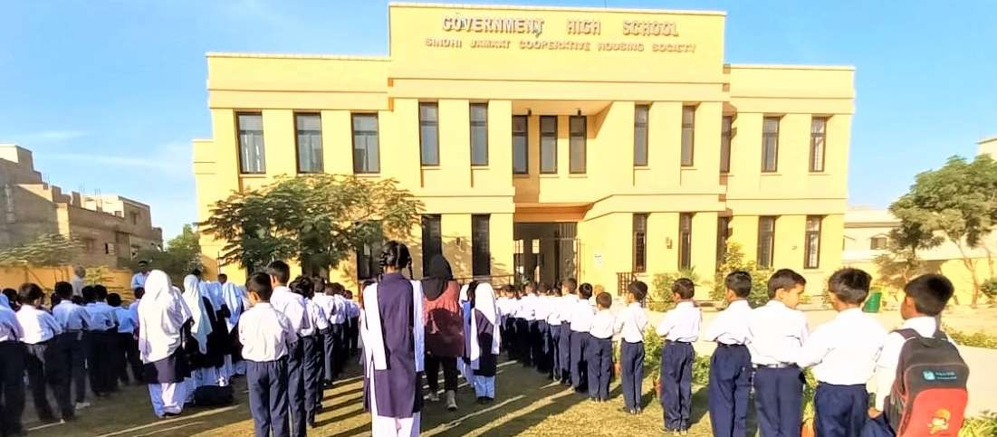
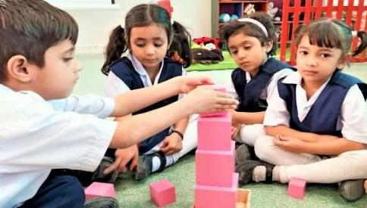
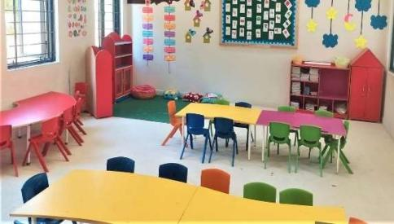
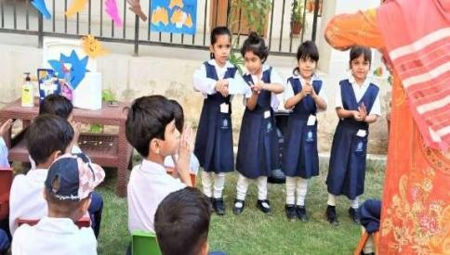

Quarterly KPIs Progress Report
Period of Performance:November 17, 2024 – February 16, 2025


Submitted by:

Sindh Madressah-tul-Islam Board
(Educational Management Organization)

To:

Teacher Resource Center
(Independent Expert)

KPI 2: Improved Staff Availability and Attendance

Availability of Staff
Details of teacher availability for each school are provided in the table below.

Teaching Staff Available in Schools
School Name | Government / Private | Teaching / Non- Teaching | Subjects / Department | Categories (SST, ST, PST, etc.) | Active (regular) | Transfer In | Deputation | New Hiring | Total
 | Govt/Private | Teaching |  | HSTs=  JSTs=  JESTs=  ECT=  O.T=  PET=  SLT=  WI=  ITT=  PST=  Private
Details of availability of non-teaching staff for each school are provided in the table below.

Non-Teaching Staff Available in School
School Name | Government / Private | Teaching / Non- Teaching | Subjects / Department | Categories (SST, ST, PST, etc.) | Active (regular) | Transfer In | Deputation | New Hiring | Total
 | Govt/Private | Non-Teaching | Primary

Staff Leaves Status

Teaching Staff |  |  | Non-Teaching Staff
School Name | Type of Leaves | No. of staff | Type of Leaves | No. of staff
 | Casual Leave |  | Casual Leave
 | Medical Leave |  | Medical Leave
 | Annual Leave |  | Annual Leave

Student Teacher Ratio (STR)
School Name | Class / Grade | STR

Functional Attendance Management

Staff Attendance
- School Name
  - Baseline Attendance:
  - Previous Quarter:
  - Current Attendance:
  - Analysis:

Teaching Staff Attendance Percentage
School Name | Month | Baseline Attendance | Attendance in the previous quarter | Current Attendance

Analysis of Non-Teaching Staff Attendance for the reporting quarter in comparison with the previous quarter and baseline data.
- School Name
  - Baseline Attendance:
  - Previous Quarter:
  - Current Attendance:
  - Analysis:

Non-Teaching Staff Attendance Percentage
School Name | Month | Baseline Attendance | Attendance in the previous quarter | Current Attendance

KPI 3: Improved Student Enrolment, Attendance, and Retention

Student Enrolment, Attendance Management, and Retention Plan
Status of Activities Planned for the Quarter based on Student Enrolment, Attendance Management, and Retention Plan
School Name | Month | Planned Activity | Status of Activity | Reason for Delay (If Applicable)

Improvement in Student Enrolment, Attendance Management, and Retention Rates

Enrollment Status of _____________________________________
Disaggregated by Gender & Grade
Grade | Initial baseline (at time of handing over) |  | Current baseline (at start of academic year) |  | Current enrolment (at the end of reporting period) |  | Percentage of improvement (from initial baseline) |  | Percentage of improvement (from current baseline)
 | Girls | Boys | Girls | Boys | Girls | Boys | Girls | Boys | Girls | Boys

Enrollment Status of _____________________________________
Disaggregated by Gender & Grade
Grade | Initial baseline (at time of handing over) |  | Current baseline (at start of academic year) |  | Current enrolment (at the end of reporting period) |  | Percentage of improvement (from initial baseline) |  | Percentage of improvement (from current baseline)
 | Girls | Boys | Girls | Boys | Girls | Boys | Girls | Boys | Girls | Boys

Enrollment Status of _____________________________________
Disaggregated by Gender & Grade
Grade | Initial baseline (at time of handing over) |  | Current baseline (at start of academic year) |  | Current enrolment (at the end of reporting period) |  | Percentage of improvement (from initial baseline) |  | Percentage of improvement (from current baseline)
 | Girls | Boys | Girls | Boys | Girls | Boys | Girls | Boys | Girls | Boys

Enrollment Status of _____________________________________
Disaggregated by Gender & Grade
Grade | Initial baseline (at time of handing over) |  | Current baseline (at start of academic year) |  | Current enrolment (at the end of reporting period) |  | Percentage of improvement (from initial baseline) |  | Percentage of improvement (from current baseline)
 | Girls | Boys | Girls | Boys | Girls | Boys | Girls | Boys | Girls | Boys

Any new admissions and drop-outs recorded during the Reporting Period, disaggregated by School, grade and gender;
New Admissions & Drop-outs Status of (GBSS No. 9 Sector 8/L SEMIS Code: 408040151)
Disaggregated by Gender & Grade
Grade | No. of New Admissions |  | No. of dropouts |  | Reason of high drop outs (If applicable)
 | Girls | Boys | Girls | Boys

New Admissions & Drop-outs Status of
Disaggregated by Gender & Grade
Grade | No. of New Admissions |  | No. of dropouts |  | Reason of high drop outs (If applicable)
 | Girls | Boys | Girls | Boys

New Admissions & Drop-outs Status of
Disaggregated by Gender & Grade
Grade | No. of New Admissions |  | No. of dropouts |  | Reason of high drop outs (If applicable)
 | Girls | Boys | Girls | Boys

New Admissions & Drop-outs Status of
Disaggregated by Gender & Grade
Grade | No. of New Admissions |  | No. of dropouts |  | Reason of high drop outs (If applicable)
 | Girls | Boys | Girls | Boys

- Student Attendance
Pictures of attendance registers are attached as a separate file for reference. However, an Excel sheet detailing individual attendance has been prepared. Aggregate attendance of students has been compiled and analyzed, and the findings are presented below, school-wise and class-wise.
Students Attendance Percentage of
Disaggregated by Gender & Grade
Grade | Month # SEP |  |  |  | Month #OCT |  |  | Month #NOV
 | Girls |  | Boys |  | Girls |  | Boys | Girls | Boys
Students Attendance Percentage of
Disaggregated by Gender & Grade
Grade | Month # SEP |  |  | Month #OCT |  |  |  | Month #NOV
 | Girls | Boys |  | Girls |  | Boys |  | Girls | Boys

Students Attendance Percentage of
Disaggregated by Gender & Grade
Grade | Month # SEP |  | Month #OCT |  | Month #NOV
 | Girls | Boys | Girls | Boys | Girls | Boys

Students Attendance Percentage of
Disaggregated by Gender & Grade
Grade | Month # SEP |  | Month #OCT |  | Month #NOV
 | Girls | Boys | Girls | Boys | Girls | Boys

- Comparison of current attendance percentage (grade and gender wise) with previous quarter;

Comparison of Students Attendance Percentage of
Disaggregated by Gender & Grade
Grade | Previous Quarter Attendance (%) |  | Current Attendance (%)
 | Girls | Boys | Girls | Boys
Total
Comparison of Students Attendance Percentage of
Disaggregated by Gender & Grade
Grade | Previous Quarter Attendance (%) |  | Current Attendance (%)
 | Girls | Boys | Girls | Boys
Total | OFF | OFF | 64% | 68.50%
Comparison of Students Attendance Percentage of
Disaggregated by Gender & Grade
Grade | Previous Quarter Attendance (%) |  | Current Attendance (%)
 | Girls | Boys | Girls | Boys
ECE
1
2
3
4
5
6
7
8
Total

Improvement in Student Enrolment, Attendance Management, and Retention Rates

KPI 4: Lesson Planning and Student Assessment System

Annual Scheme of Studies (Not Applicable for RFP 1)

Lesson Planning

Formative Assessments (In-House)

Summative Assessments (Internal)

Summative Assessments (External)
Matric Annual Board Result was announced in which all the grouped and constructed school secure 100% result.
School Name GBSS 8L SECTOR 9
SAT Results |  | Annual Board Examinations
Last year/before EMO’s Operations | Current year | Last year before EMO’s Operations / | Current year
 |  | 100% | 100%

KPI 5: Continuous Professional Development of Staff

Staff Trainings

Quality Assurance of CPD Sessions
Following are the details of the quality assurance.

School Name | No. of Staff (Teaching/Non-teaching)  (EMO/Govt) | Key findings of the QA | Training attended since TNA of this academic year | Key implications of attended trainings on work performance

KPI 6: School Repair and Maintenance; Community Engagement

Repair and Maintenance of Schools within the Group/Cluster
School name | Planned activity | Status in the reporting quarter

Meetings with School Management Committee (SMC)
Students’ attendance was one of the major issues that the schools were facing therefore SMC meetings were called in all schools to discuss the issue and decide the way forward. Meting Minutes and Pictures are attached as Annexure 7.

School Name | Key Agendas of Meeting | Venue and Date | Key Actions Points

Improved Community Outreach
S

School name | Planned activity | Status in the reporting quarter | Date of Activity | Description of Activity

Parent-Teacher Meetings (PTMs)
.
School Name | Agendas | Date | No. of Participation

KPI 7: Improved Health and Hygiene Practices

Health and Hygiene Activities
School name | Planned activity | Status in the reporting quarter | Date of Activity | Description of Activity

Student Sports and Extra-Curricular Activities
. According to the AMP and academic calendar, sports activities are scheduled for next academic year.
As it has been planned in December so it is not added in this quarter
School name | Planned activity | Status in the reporting quarter | Date of Activity | Description of Activity

Non-KPIs
Please provide details about the following for each school (including main and group schools):
.

Reporting formats developed as per Concession Agreement deliverables
S. No | Annexures | Description of Annexures | Whether developed within stipulated time | Implemented in letter and spirit
1 | IV | Guideline for the capacity test
2 | V | Reporting forms  Types:
3 | XI | Employment Criteria

Notice of Annuity Amount Payment

- [Provide activity detail]
- [was detected by Compliance Manager in case of RFP#4 and 5]
- Organization response if any to para 2
- [Status]

Conclusions

Challenges and Red Flags
List noteworthy challenges faced during the Reporting Period, and any strategies implemented to address these challenges. (Not limited to 5 challenges)

Lessons Learned
Provide briefs on lessons learned by EMO during the Reporting Period (not limited to 5 lesson learnt)

